

**MSPM’S**

**Deogiri Institute of Engineering and Management Studies, Aurangabad**

**Department of Computer Science and Engineering**

Report on

**Computer Architecher & organization**

Submitted By

**1) Pankaj Manohar Kalbande ( 26103 )**

**2) Kalyan Kathar( 26104 )**

Under the Guidance of

Prof. Pankaj Durole

Department of Computer science and Engineering

(Deogiri Institute of Engineering and Management Studies)

2019-2020



CERTIFICATE

This is to Certify that Mr. **Pankaj Kalbande** and Mr. **Kalyan Kathar**

Seat No.26103 & 26104 has completed a report writing on Computer Architecher & organization

**Pro.Pankaj Durole**  **Dr.S.Kalyankar Dr.UlhasShiukar**

**Subject Teacher H.O.D. Director**

***Hp******Envy 13***

## 

## **Pros :**

 Attractive, lightweight chassis; Fast performance; Bright display; Long battery life (on FHD model); Crisp, powerful speakers

**Cons :**4K model has short battery life; No Thunderbolt 3

**Verdict :**The HP Envy 13 is a near-perfect Ultrabook that offers fast performance, long battery life and a bright display at a reasonable price.

|  |  |
| --- | --- |
| Price: | ₹ 75,990.00 . |
| You Save: | ₹ 10,799.00 (12%) |
|  | Inclusive of all taxes |

**EMI** starts at ₹3,577. No Cost EMI available

## HP Envy 13-ah0043tx 2018 13.3-inch Laptop Information

Technical Details

|  |  |
| --- | --- |
| Brand | HP |
| Series | Envy |
| Colour | Natural Silver |
| Item Height | 15 Millimeters |
| Item Width | 21.2 Centimeters |
| Screen Size | 13.3 Inches |
| Maximum Display Resolution | 1920x1080 |
| Item Weight | 1.21 Kg |
| Product Dimensions | 30.7 x 21.2 x 1.5 cm |
| Batteries: | 1 Lithium ion batteries required. (included) |
| Item model number | 13-ah0043tx |
| Processor Brand | Intel |
| Processor Type | Core i5 |
| Processor Speed | 3.40 GHz |
| Processor Count | 4 |
| RAM Size | 8 |
| Memory Technology | LPDDR3-2133 SDRAM |
| Computer Memory Type | GDDR5 |
| Maximum Memory Supported | 8 GB |
| Hard Drive Size | 256 GB |
| Hard Disk Technology | Flash Memory Solid State |
| Hard Drive Interface | Solid State |
| Audio Details | Headphones |
| Speaker Description | Bang & Olufsen; quad speakers; HP Audio Boost 2.0 |
| Graphics Coprocessor | NVIDIA GeForce MX150 (2 GB GDDR5 dedicated) |
| Graphics Card Description | dedicated |
| Graphics Card Ram Size | 2 GB |
| Connectivity Type | Intel 802.11ac (2x2) Wi-Fi and Bluetooth 4.2 Combo |
| Wireless Type | 801.11ac |
| Number of USB 3.0 Ports | 2 |
| Number of Audio-out Ports | 1 |
| Number of Microphone Ports | 1 |
| Wattage | 53.2 Watts |
| Optical Drive Type | None |
| Card Reader | MicroSD |
| Hardware Platform | PC |
| Operating System | Windows 10 |
| Supported Software | Preinstalled iQiyi |
| Average Battery Life (in hours) | 10 Hours |
| Lithium Battery Energy Content | 53.2 Watt Hours |
| Lithium battery Weight | 0.85 Grams |
| Number of Lithium Ion Cells | 4 |
| Included Components | Laptop, Battery, AC Adapter |
|  |  |

Warranty & Support

**Warranty Details:** 1 year onsite domestic warranty from HP covering manufacturing defects and not covering physical damage. Register on brand website to activate warranty.For FAQs on warranty, link to check and update warranty start date, see Warranty FAQ PDF under Technical Specifications. Reach HP customer care at the 1800 200 0047(toll free), between 9am - 9pm. This product is eligible for 10 Days Replacement in case of any product damage, defects or different product being shipped.…

The new HP Envy 13 is everything I was hoping the new MacBook Air would be: fast, attractive and affordable. That doesn't come as a surprise.

HP could simply have cloned that model, added new components and re-released it, and it still would have been one of the best ultraportable laptops around.

Instead, the company gave us an even better version, with a more elegant design, a bright and vivid display, and top-notch speakers. Combine that with long battery life (on the 1080p version), a comfortable keyboard and a reasonable price and it becomes hard to see why anyone would buy the [MacBook Air](https://www.laptopmag.com/reviews/laptops/apple-macbook-air-2019) over the Envy 13.

### HP Envy 13 Price and Configuration Options

We reviewed two versions of the HP Envy 13: the base FHD version with an Core i5 CPU and a 4K model with a Core i7 processor.

The base Envy 13 we tested costs $799

( 57,418 ₹ )and comes with a 1080p touch screen, [Core i5-8265U CPU](https://www.laptopmag.com/articles/cpu-comparison), 8GB of RAM and a 256GB SSD. If you need more power, HP sells another FHD model with a Core i7-8565U CPU, 8GB of RAM and a 256GB SSD for $999 (71,791₹).

For just $20 (1437₹)more, you can upgrade from UHD 620 integrated graphics to an Nvidia GeForce MX250 graphics card while an extra $120 (8623 ₹ )doubles RAM from 8GB to 16GB.

The 4K unit we reviewed costs $1,159 (83289₹) and has a Core i7-8565U CPU, 16GB of RAM, a 512GB SSD and MX250 graphics. If that's not enough storage, a 1TB drive costs an additional $220(15809₹).

**Design**

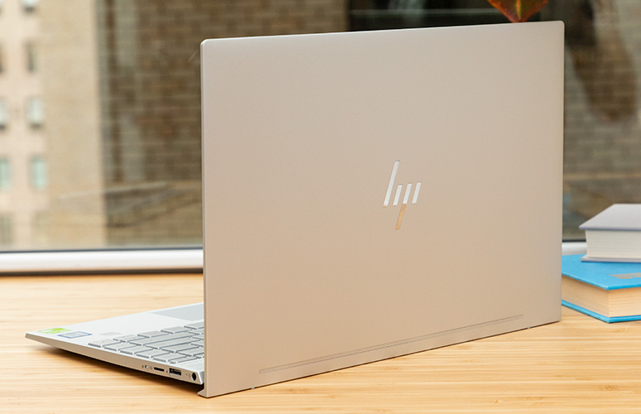

Open the lid, and you'll find an interior that resembles that of the gorgeous [Spectre x360](https://www.laptopmag.com/reviews/laptops/hp-spectre-x360-13-inch-2019). The most obvious similarity is the triangular pattern on the speaker grill located just above the keyboard. Some folks might complain about a lack of contrast between the laptop's silver keys and deck, but I quite like the pairing. I do wish HP hid the gray antenna strip underneath the chassis, but that's a small knock on what is otherwise a pristinely packaged notebook.

Also on the deck is a slim power button with an LED strip, opposite a [fingerprint sensor](https://www.laptopmag.com/articles/how-to-use-your-fingerprint-reader). A chrome trim around the touchpad and some unobtrusive Envy and HP branding give this reasonably-priced notebook a premium aesthetic.

Adopted from HP's pricier Spectre laptops are the Envy 13's slim display bezels. While not as thin as those on some Dell and Asus laptops, the narrow black frame around the Envy's panel provides an immersive viewing experience without sacrificing the webcam.



### **Ports**

HP used a clever expanding-flap mechanism called a "drop jaw" to fit [USB 3.1 Type-A ports](https://www.laptopmag.com/articles/port-and-adapter-guide) on each side of the Envy 13. You can use these inputs to connect legacy peripherals -- like mice, keyboards or [external webcams](https://www.laptopmag.com/articles/best-webcams) -- without a dongle, but we worry about the long-term reliability of this extra moving part.

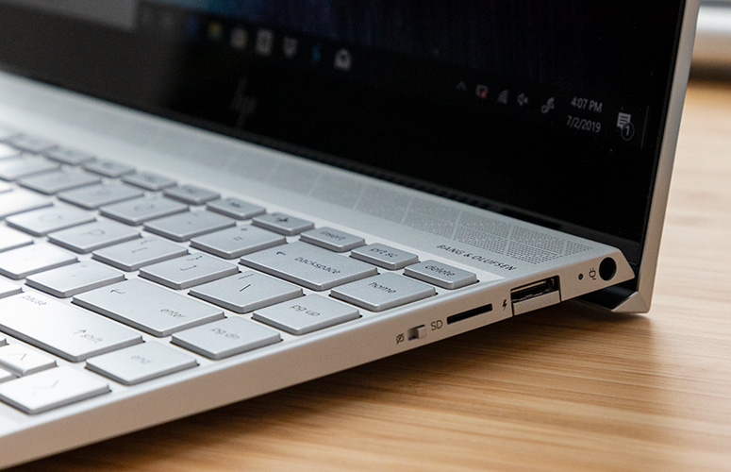

Also on the left side of the Envy 13 is a [USB-C port](https://www.laptopmag.com/articles/best-usb-type-c-accessories-cables) and a headphone jack, while the right side has a microSD-card reader and a power jack.

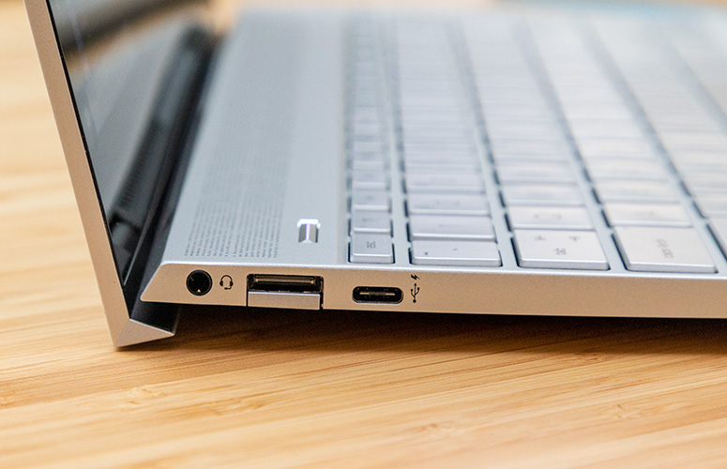

Unfortunately, there is no [Thunderbolt 3 port](https://www.laptopmag.com/articles/thunderbolt-3-guide).

**Display**

The 13.3-inch, 1080p non-touch display on the base Envy 13 is just as good as the 4K touch option, if not better. While both touch screen panels are very sharp and bright, the FHD version is even more vivid than the higher-res panel.

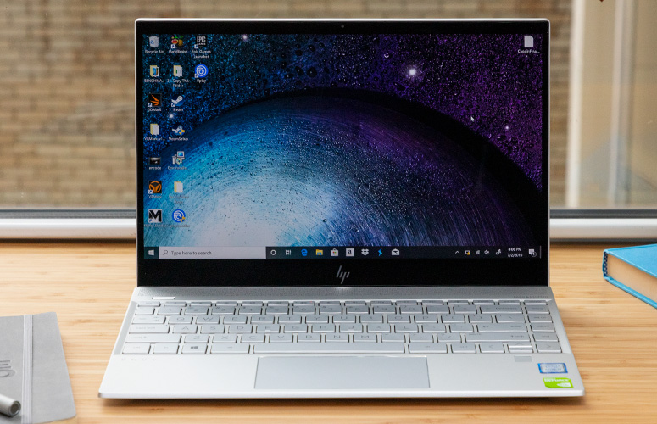

While the 4K screen looked plenty saturated, its colors didn't look any more lively than those on the 1080p display.

Keyboard and Touchpad

The fingers appreciated the 1.2 millimeters of key travel on the Envy 13's keyboard, even though it doesn't reach our 1.5mm preference. The generous size and spacing of the island-style keys on the Envy 13 also make typing a joy.

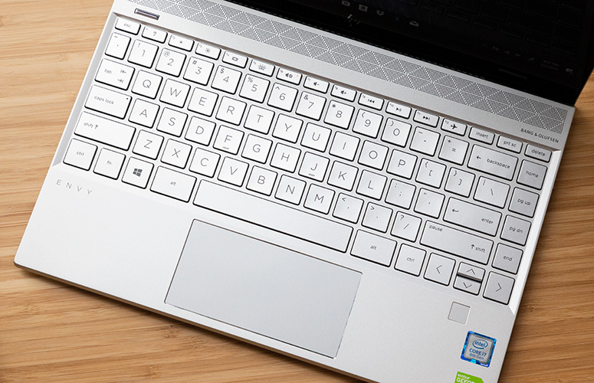

**Performance**

We tested two versions of the Envy 13: a base model with a Core i5-8265U CPU and 8GB of RAM and a 4K model with an [Intel Core i7-8565U CPU](https://www.laptopmag.com/articles/cpu-comparison) and 16GB of [RAM](https://www.laptopmag.com/articles/how-much-ram).



The 4K Envy 13 breezed through my real-world performance test, swiftly loading 20 [Google Chrome](https://www.tomsguide.com/us/pictures-story/283-best-google-chrome-extensions.html) tabs with multiple 1080p [YouTube](https://www.tomsguide.com/us/youtube-music-youtube-premium-faq,news-27226.html)videos playing in the background. I was then able to download the trailer for Mulan while watching Season 3 of [Stranger Things](https://www.tomsguide.com/round-up/what-to-watch-after-stranger-things) on [Netflix](https://www.tomsguide.com/us/pictures-story/764-netflix-hidden-gems.html), all without any stuttering. The laptop's fans kicked on at this point, but they weren't bothersome.

The Core i5 and Core i7 versions of the Envy 13 did an excellent job on our synthetic benchmark tests, scoring a 15,147 and 15,738 on the Geekbench 4 evaluation, respectively. The Notebook 9 Pro (15,432; Core i7-8565U) falls between those results, while both Envy 13 models topped the Surface Laptop 2 (12,744; Core i5-8250U), the ZenBook S UX333UA (15,110; Core i5-8265U) and the category average (15,085). They also embarrassed the MacBook Air (7,880).

### **Graphics**

Surprise, surprise -- our 4K Envy 13 came with a [discrete graphics card](https://www.laptopmag.com/articles/gpu-comparison). While the Nvidia GeForce MX250 GPU isn't meant for demanding gaming, it is a step up from [integrated graphics](https://www.laptopmag.com/articles/intel-hd-graphics-comparison) as proven by comparing it to the UHD 620 GPU in the FHD model.

The MX250-equipped Envy 13 scored a 116,575 on the Ice Storm Unlimited benchmark while the base model scored a 82,270. Upgrading to the discrete graphics gives the Envy 13 better performance than the Notebook 9 Pro (61,662; UHD 620), Surface Laptop 2 (71,647; UHD 620) and the premium laptop average (86,937).

**Audio**

HP went all out with the Envy, placing dual speakers on the underside of the chassis along with a third, top-firing driver above the keyboard. Devon Gilfillian's funky jam "Here and Now" boomed smooth, soulful tunes throughout my small apartment. The twang of the electric guitar played nicely with the thudding percussion but never overshadowed Gilfillian or the female backup vocals.

Bang & Olufsen software comes preinstalled on the Envy 13, with equalizer controls so you can adjust the bass, midrange and treble to your liking. But even out of the box, you'll enjoy great sound without having to bust out your [headphones](https://www.laptopmag.com/articles/best-noise-cancelling-headphones).

### **Battery Life**

Get an Envy 13 with the 1080p non-touch display if battery life is important to you.

The FHD model endured for 11 hours and 11 minutes whereas the 4K model lasted only 4 hours and 36 minutes on our [battery test](https://www.laptopmag.com/articles/all-day-strong-longest-lasting-notebooks), which involves continuous web browsing over Wi-Fi at 150 nits of brightness.

### **Webcam**

The 720p [webcam](https://www.laptopmag.com/articles/best-webcam-covers) on the Envy 13 is nothing to write home about.

On the right edge of the Envy 13 is a physical kill switch that cuts the power to the webcam so you can feel reassured that nobody is snooping on you.

### **Heat**

Leave the [lapdesk](https://www.laptopmag.com/articles/best-lap-desks) at home - you don't have to worry about the Envy 13 overheating.

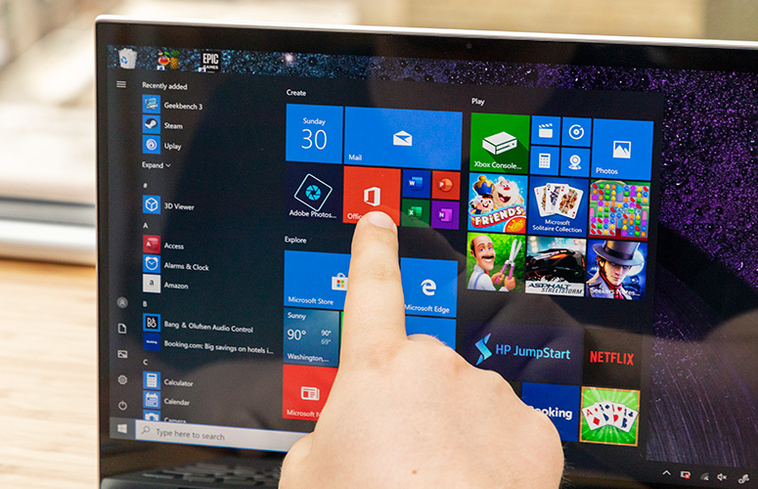

After played a 15-minute, full-HD video in full screen, the touchpad on the HP Envy 13 with a Core i7 CPU rose to only 83 degrees Fahrenheit while the keyboard (87 degrees) and underside (90 degrees) also remained well below our 95-degree comfort threshold. Even the toastiest part of the machine, the lower-left edge on the underside, topped out at 94 degrees.

### **Software and Warranty**

It's a shame that a laptop with such beautiful hardware ships with such ugly software. Pre-installed on this machine are entirely too many programs that could either be packaged together or omitted altogether.

HP provides an app called Audio Switch, which simply lets you switch your audio input/output between the internal speakers and headphones. As the same implies, HP's Command Center is where you can get information about your Envy 13 but also switch the thermal profiles between comfort and performance. Along with support documentation, HP also bundles in a setup program called JumpStart, a program for connecting printers and a redundant system-info app called Event Utility.

Also installed on the Envy 13's Windows 10 Home OS are several [Microsoft apps](https://www.laptopmag.com/articles/windows-10-delete-microsoft-apps), including Simple Solitaire, Candy Crush Friends and Your Phone. Other third-party apps include Booking.com, Netflix and [McAfee Security](https://www.tomsguide.com/us/mcafee-internet-security,review-3190.html).

HP ships the Envy 13 with a one-year warranty. See how HP did on our [Tech Support Showdown](https://www.laptopmag.com/articles/hp-tech-support) and [Best and Worst Brands](https://www.laptopmag.com/articles/hp-brand-rating) ranking.

### **Bottom Line**

The Envy 13 has cemented its standing as the ultimate laptop for college students or travelers. Along with 11-plus hours of battery life (on the FHD model), the Envy 13 has a sleek, ultraportable chassis, fast performance, and powerful speakers. Best of all, the Envy 13 starts at a reasonable $799, which is hundreds less than the competition. In many ways, the Envy 13 is what we wanted the new MacBook Air to be.

# Asus ZenBook 13 UX333 FA



[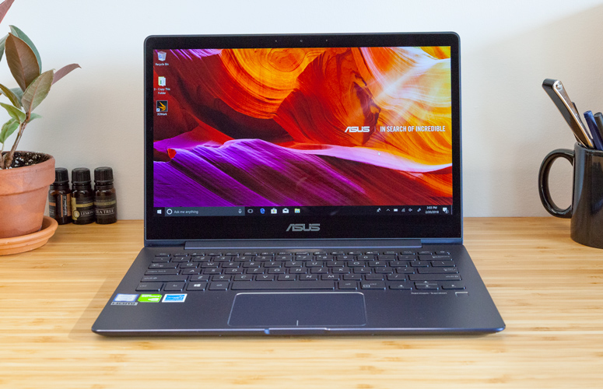](https://www.laptopmag.com/reviews/laptops/asus-zenbook-13-ux331un)

**The Pros**

Beautiful design; Solid performance; Long battery life

**The Cons**

Slower-than-average transfer speeds; Low-res webcam

**Verdict**

The Asus ZenBook 13 UX333 FA is a beautiful blue machine with strong performance and long battery life, but it could use a faster SSD.

|  |  |
| --- | --- |
| Price: | ₹ 80,990.00 . |
| You Save: | ₹ 18,910.00 (19%) |
|  | Inclusive of all taxes |

**EMI** starts at ₹3,812. No Cost EMI available

## Product information

Style: **Intel Core i5-8265U / 256GB PCIe SSD**

Technical Details

|  |  |
| --- | --- |
| Brand | Asus |
| Model | UX333FA-A4046T |
| Model Name | ZenBook 13 |
| Item Weight | 1.19 Kg |
| Product Dimensions | 18.9 x 30.2 x 1.7 cm |
| Batteries: | 1 Lithium Polymer batteries required. (included) |
| Item model number | UX333FA-A4046T |
| RAM Size | 8 GB |
| Flash Memory Installed Size | 256.0 |
| Ram Memory Installed Size | 8 GB |
| Ram Memory Maximum Size | 8 GB |
| Ram Memory Technology | LPDDR3 |
| Hard Drive Size | 256 GB |
| Hard Disk Technology | Flash Memory Solid State |
| Optical Drive Type | None |
| Operating System | Windows 10 |
| Processor Brand | Intel |
| Processor Speed | 3.90 GHz |
| Processor Type | Core i5 |
| Graphics Coprocessor | Intel UHD Graphics 620 |
| Included Components | Laptop, AC Adapter, Sleeve, USB3.0 to RJ45 cable, User Guide, Manuals |
| Screen Size | 13.3 Inches |
| Display Type | LED-Backlit |
| Display Resolution Maximum | 1920x1080 |
| Batteries Included | Yes |
| Batteries Required | Yes |
| Battery Cell Composition | Lithium Polymer |
| Connector Type | Wireless |

Warranty & Support

**Warranty Details:** 1 year global warranty

**Review**

The Asus ZenBook 13 UX331UN is blue. Very blue. Honestly, that's its defining feature. It's a $999 laptop with solid performance from an [8th Gen](https://www.laptopmag.com/articles/intel-8th-gen-core-faq) Intel Core i5 CPU, 8GB of RAM and an [Nvidia GeForce MX150 GPU](https://www.laptopmag.com/articles/gpu-comparison). What will get you, however, is its shiny, cobalt chassis that reflects light in just the right way. It also lasts over 9 hours on a charge. Sure, its 256GB SSD isn't as fast as competitors' NVMe SSDs, and the webcam could be sharper. But when you look at how blue-tiful this thing is, you may fall in love with this, the [best Asus laptop](https://www.laptopmag.com/best-asus-laptops).

**Design**

Everyone I showed the ZenBook 13 to let out a low "oooh." And with good reason: This laptop sure is pretty.

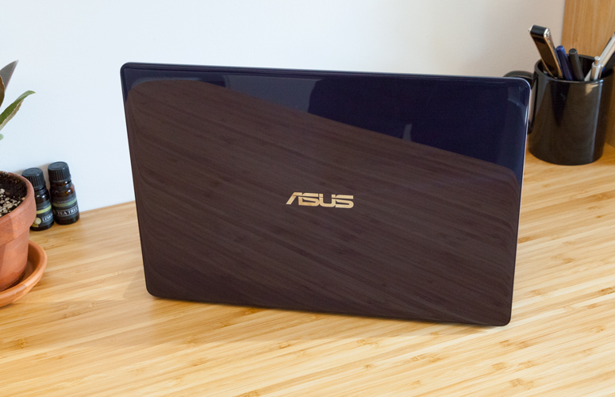

The ZenBook is a dark navy blue, and while the lid maintains Asus' iconic designs with its logo surrounded by concentric circles, they've added something here. Now there's a shiny layer on top that feels like plastic but provides a beautiful, glass-like shine. It's like a cake with a perfect mirror glaze. Sure, it collects fingerprints faster than Boy Scouts collect merit badges, but the way light shines off

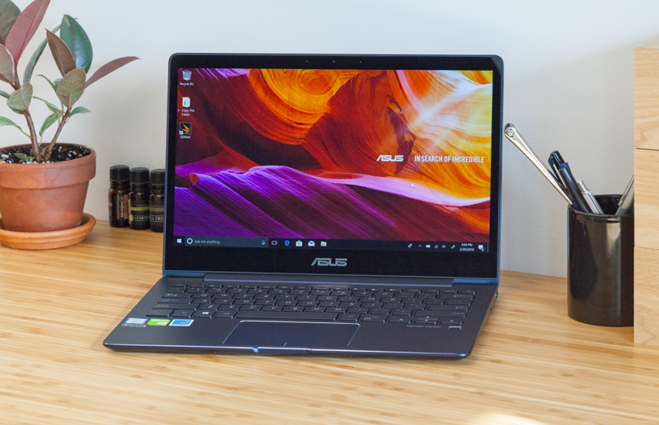

With the laptop open, you'll find the 13.3-inch, 1080p display with a fairly thin bezel, the navy aluminum chassis, an island-style keyboard and a fingerprint reader (which, mercifully, [is not located on the touchpad](https://www.laptopmag.com/articles/touchpad-changes-are-bad). Asus is learning!).

On the left side of the ZenBook are an HDMI output, a USB 3.0 port and a [Type-C port](https://www.laptopmag.com/articles/usb-type-c-faq), as well as room for a traditional barrel charger. The right side is where you'll find a microSD card, [headphone](https://www.tomsguide.com/us/best-headphones,review-1988.html) jack and another USB 3.0 p

At 12.2 x 8.5 x 0.5 inches and 2.7 pounds, the ZenBook falls in the middle of the pack when it comes to size. The [HP Envy 13t](https://www.laptopmag.com/reviews/laptops/hp-envy-13t) is 2.9 pounds and 12.9 x 8.9 x 0.5 inches, the [Dell XPS 13](https://www.laptopmag.com/reviews/laptops/dell-xps-13) is 11.9 x 7.8 x 0.5 inches and 2.7 pounds, and the [Lenovo Yoga 720](https://www.laptopmag.com/reviews/laptops/lenovo-yoga-720-13-inch) is 12.2 x 8.4 x 0.6 inches and

### **Display**

The ZenBook's [screen](https://www.laptopmag.com/articles/laptop-screen-guide) is more than serviceable, with decent color and [plenty of luminosity](https://www.laptopmag.com/benchmarks/display-brightness). Despite high scores, though, I hesitate to say it's any better than competing displays. When I watched a trailer for [Deadpool 2](https://www.tomsguide.com/us/pictures-story/1211-best-worst-marvel-movies.html), the hero's suit was the perfect shade of dark red, but the yellow jumpsuits in a prison were dull, even against a gray background. And I wished I could turn up the brightness just a teeny bit.

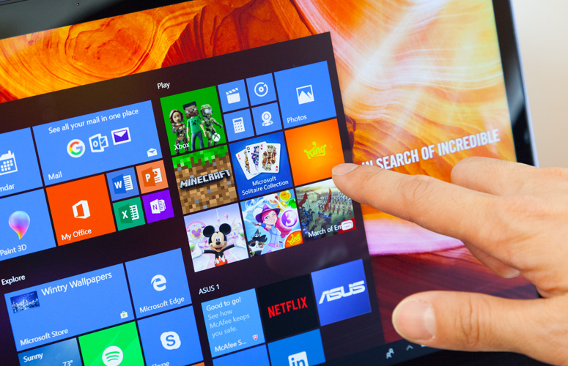

The display covers 119 percent of the [sRGB color gamut](https://www.laptopmag.com/benchmarks/color-gamut), which is higher than the premium-laptop average. However, that's more vivid than the average (110 percent), the Envy (106 percent) and the XPS 13 (117 nits), but less evocative than the Yoga's 171 nits.

**MORE:**

The ZenBook averaged a brightness of 296 nits on our light meter, which is slightly higher than the average (287 nits), as well as the scores from the Yoga (255 nits) and the Envy 13t (248 nits). But it was considerably dimmer than the XPS 13 (372 nits).

### Keyboard and Touchpad

Because it has 1 millimeter of travel and 68 grams of force required to press the keys, one would think the keyboard is too shallow. Surprisingly, it's decent. Yes, I prefer deeper keys, but ZenBook's are nice and clicky, like a slightly better version of what Apple offers on its [MacBooks](https://www.laptopmag.com/articles/macbook-vs-air-vs-pro). On the 10fastfingers.com typing test, I reached 115 words per minute with a 3-percent error rate, which is standard for me.

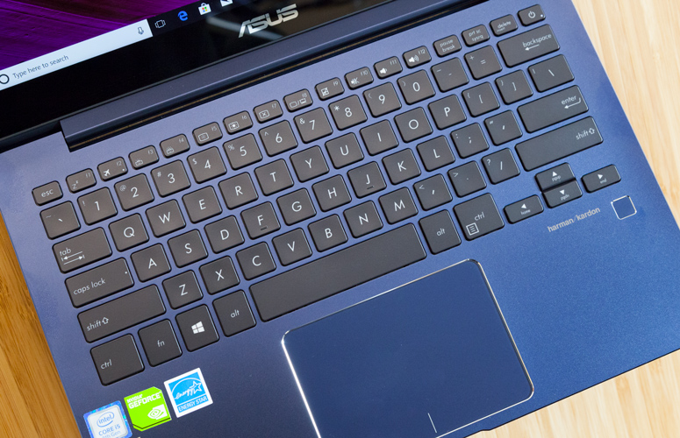

The 4.1 x 2.8-inch touchpad is roomy and responsive. I could quickly flick programs to the task bar with a downward three-finger swipe and two-finger scroll on web pages with ease.

### **Audio**

The speakers on the ZenBook 13 were surprisingly good for a laptop this size. When I listened to Kendrick Lamar and SZA's "All The Stars," the speakers did an excellent job of emphasizing the vocals above the track while still keeping snappy drums, strings and synthesized beats. During the chorus, the lows felt a little flat, though I was able to pull them up slightly using the included ICEpower audio app.

### **Performance**

The ZenBook 13 comes with an [Intel Core i5-8250 CPU](https://www.laptopmag.com/articles/cpu-comparison), 8GB of [RAM](https://www.laptopmag.com/articles/how-much-ram), a [256GB SATA SSD](https://www.laptopmag.com/articles/ssds-are-worth-it)and an [Nvidia GeForce MX150 GPU](https://www.laptopmag.com/articles/gpu-comparison). That's plenty for multitasking; I had more than 25 tabs open in [Google Chrome](https://www.tomsguide.com/us/pictures-story/283-best-google-chrome-extensions.html), including one streaming a 1080p clip of The Daily Show with Trevor Noah from [YouTube](https://www.tomsguide.com/us/youtube-tv-faq,review-5059.html), without seeing as much as a hiccup.



On the Geekbench 4 [overall performance](https://www.laptopmag.com/benchmarks/overall-performance) test, it earned a score of 12,999, handily surpassing the 9,575-point premium laptop average as well as the Yoga 720 (10,622, Intel Core i5-8250U) and the Envy 13t (12,225, Intel Core i7-8550U). The Dell XPS 13 was the winner, though, outperforming the ZenBook with a score of 14,180 (with a Core i7-8550U. A model with a Core i5-8250U notched a score of 13,254).

The speakers on the ZenBook 13 were surprisingly good for a laptop of this size.

It took Asus' notebook 25 seconds to copy 4.97GB of files, for a rate of 203.6 megabytes per second. The premium-laptop [average](https://www.laptopmag.com/benchmarks/hard-drive-speed) is swifter -- 267.5 MBps -- and every competitor was faster than the Asus. The Envy reached 212 MBps, the Yoga 720 hit 282 MBps and the XPS 13 was the fastest, at 339.2MBps.

On our [Excel macro test](https://www.laptopmag.com/benchmarks/cpu-performance), the ZenBook took 1 minute and 10 seconds to pair 65,000 names and addresses, handily beating the average (1:45), the Yoga 720 (2:09) and the Envy (1:33). The XPS 13 was fastest, at 1:06 on a Core i7 CPU, but its Core i5 variant was a few seconds behind, at 1:15.

The ZenBook took 23 minutes and 2 seconds to transcode 4K video to 1080p in our Handbrake video-editing test. That time was longer than the average (22:11), the Envy (22:44) and the XPS 13 (18:17). The Yoga was the slowest, at 28:20.

Nvidia's MX150 does give the ZenBook a leg up in [graphics](https://www.laptopmag.com/benchmarks/graphics-performance). It ran Dirt 3 at 114 frames per second, which is far smoother than the average (47 fps), the Envy 13t (48 fps) and the Yoga 720 (56 fps).

### **Battery Life**

Your ZenBook will last a while on a charge. It ran for 9 hours and 11 minutes on the [Laptop Mag Battery Test 2.0](https://www.laptopmag.com/articles/all-day-strong-longest-lasting-notebooks), which continuously browses websites, graphics tests and videos over Wi-Fi at 150 nits of brightness.

That's higher than the premium-laptop average (8:25) and the Yoga 720 (8:13), but the Dell XPS 13 has more endurance, lasting a whopping 11:59.

### **Webcam**

Asus continues a not-so-grand tradition of crappy [webcams](https://www.laptopmag.com/articles/best-webcams) with the ZenBook 13. Its 480p front-facing shooter produces blurry images. A shot that I took in our well-lit office didn't capture fine details, like the unfortunate popcorning on our ceiling or the hairs on my head

### **Heat**

You won't have to worry about the ZenBook 13 overheating; it stayed nice and cool during our heat tests. After streaming 15 minutes of HD video from YouTube, it measured 84 degrees Fahrenheit on the touchpad, 88 degrees between the G and H keys and 91 degrees on the underside. ll of those temperatures are well below our comfort threshold of 95 degrees.

### **Software and Warranty**

Asus' own preloaded software is minimal. It includes the company's Splendid Utility, which allows you to change the color temperature of the screen, and Asus Live Update, which helps you to check for and install the newest drivers on your computer. The only big stain is the bundled McAfee Security.

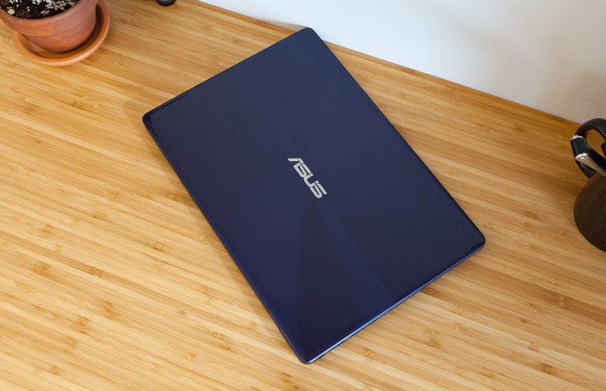

The rest of the junk is built into [Windows 10](https://www.laptopmag.com/articles/how-to-use-windows-10), including [Netflix](https://www.tomsguide.com/us/pictures-story/838-best-movies-on-netflix.html), Disney Magic Kingdom, March of Empires: War of Lords, Bubble Witch 3 Saga, Candy Crush Soda Saga, Dolby Access, [LinkedIn](https://www.tomsguide.com/us/linkedin-app-bluetooth,news-24937.html) and Autodesk SketchBook.

Asus sells the ZenBook 13 UX331UN with a one-year warranty. See how the company performed on our [Tech Support Showdown](https://www.laptopmag.com/articles/tech-support-showdown) and [Best and Worst Brands](https://www.laptopmag.com/articles/laptop-brand-ratings) ranking.

### **Bottom Line**

The Asus ZenBook 13 UX331UN offers strong performance, long battery life and a striking design that will make people at Starbucks do a double-take.

If you want to spend less, you'll want to go for the [Lenovo Yoga 720](https://www.laptopmag.com/reviews/laptops/lenovo-yoga-720-13-inch), which starts at $849.99. You'll get similar specs but we dinged it for a flat keyboard and a dim display.

For stronger performance, opt for the [Dell XPS 13](https://www.laptopmag.com/reviews/laptops/dell-xps-13). You'll need to pay $1,199 for competing specs, but you'll get an even better display, longer battery life and stronger performance, thanks to Dell's cooling system.

That makes the ZenBook 13 a fine compromise for just about anyone. It's (just) under a thousand dollars, and while I wish the SSD were faster and the webcam were sharper, you'll get otherwise strong performance to get you through the day and beyond.

**INSTRUCTIONS SET**

Table lists some common instructions. * denotes this entry is multiple opcodes where the * denotes a suffix.

|  |  |  |  |
| --- | --- | --- | --- |
| Opcode | Meaning | Opcode | Meaning |
| MOV | Move to/from/between | AND/OR/XOR/NOT | Bitwise operations |
|  | memory and registers |  |  |
| CMOV* | Various conditional moves | SHR/SAR | Shift right logical/arithmetic |
| XCHG | Exchange | SHL/SAL | Shift left logical/arithmetic |
| BSWAP | Byte swap | ROR/ROL | Rotate right/left |
| PUSH/POP | Stack usage | RCR/RCL | Rotate right/left through carry |
|  |  |  | bit |
| ADD/ADC | Add/with carry | BT/BTS/BTR | Bit test/and set/and reset |
| SUB/SBC | Subtract/with carry | JMP | Unconditional jump |
| MUL/IMUL | Multiply/unsigned | JE/JNE/JC/JNC/J* | Jump if equal/not |
|  |  |  | equal/carry/not carry/ many |
|  |  |  | others |
| DIV/IDIV | Divide/unsigned | LOOP/LOOPE/LOOPNE | Loop with ECX |
| INC/DEC | Increment/Decrement | CALL/RET | Call subroutine/return |
| NEG | Negate | NOP | No operation |
| CMP | Compare | CPUID | CPU information |

**Memory**

**HDD**

Memory is the most essential element of a computing system because without it computer can’t perform simple tasks. Computer memory is of two basic type – Primary memory / Volatile memory and Secondary memory / non-volatile memory. Random Access Memory (RAM) is volatile memory and Read Only Memory (ROM) is non-volatile memory.

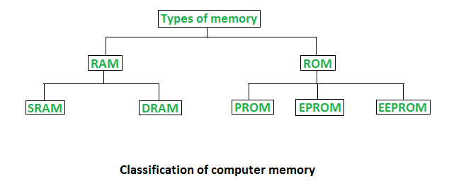

**Random Access Memory (RAM) –**

* It is also called as *read write memory* or the*main memory* or the *primary memory*.
* The programs and data that the CPU requires during execution of a program are stored in this memory.
* It is a volatile memory as the data loses when the power is turned off.
* RAM is further classified into two types- *SRAM (Static Random Access Memory)* and *DRAM (Dynamic Random Access Memory)*

**Double Data Rate 4 Synchronous Dynamic Random-Access Memory**, officially abbreviated as **DDR4 SDRAM**, is a type of [synchronous dynamic random-access memory](https://en.wikipedia.org/wiki/Synchronous_dynamic_random-access_memory) with a high [bandwidth](https://en.wikipedia.org/wiki/Bandwidth_(computing)) ("[double data rate](https://en.wikipedia.org/wiki/Double_data_rate)") interface.

Released to the market in 2014, it is one of the latest variants of [dynamic random-access memory](https://en.wikipedia.org/wiki/Dynamic_random-access_memory) (DRAM), of which some have been in use since the early 1970s, and a higher-speed successor to the [DDR2](https://en.wikipedia.org/wiki/DDR2_SDRAM) and [DDR3](https://en.wikipedia.org/wiki/DDR3_SDRAM) technologies.

DDR4 is not compatible with any earlier type of random-access memory (RAM) due to different signaling voltage and physical interface, besides other factors.

DDR4 SDRAM was released to the public market in Q2 2014, focusing on [ECC memory](https://en.wikipedia.org/wiki/ECC_memory), while the non-ECC DDR4 modules became available in Q3 2014, accompanying the launch of [Haswell-E](https://en.wikipedia.org/wiki/Haswell-E" \o "Haswell-E) processors that require DDR4 memory.

## Features

The primary advantages of DDR4 over its predecessor, DDR3, include higher module density and lower voltage requirements, coupled with higher [data rate transfer](https://en.wikipedia.org/wiki/Bit_rate#Goodput_(data_transfer_rate)) speeds. The DDR4 standard allows for [DIMMs](https://en.wikipedia.org/wiki/DIMM) of up to 64 [GB](https://en.wikipedia.org/wiki/Gibibyte) in capacity, compared to DDR3's maximum of 16 GB per DIMM.

Unlike previous generations of DDR memory, [prefetch](https://en.wikipedia.org/wiki/Prefetch_buffer" \o "Prefetch buffer) has *not* been increased above the 8n used in DDR3 the basic burst size is eight words, and higher bandwidths are achieved by sending more read/write commands per second. To allow this, the standard divides the DRAM banks into two or four selectable bank groups, where transfers to different bank groups may be done more rapidly.

Because power consumption increases with speed, the reduced voltage allows higher speed operation without unreasonable power and cooling requirements.

DDR4 operates at a voltage between 1.2 V and 1.4 V with a frequency between 800 and 2133 MHz (DDR4-1600 through DDR4-4266), compared to frequencies between 400 and 1067 MHz and voltage requirements of 1.5 or 1.65 V of DDR3. Due to the nature of DDR, speeds are typically advertised as doubles of these numbers (DDR3-1600 and DDR4-2400 are common, with DDR4-3200 and DDR4-4800 available at high cost). Although a low-voltage standard has yet to be finalized (as of August 2014), it is anticipated that low-voltage DDR4 will run at a voltage of 1.05 V, compared to DDR3's low-voltage standard ([DDR3L](https://en.wikipedia.org/wiki/DDR3L)) which requires 1.35 V to operate.

## **Timeline**

[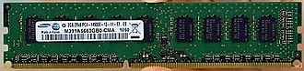](https://en.wikipedia.org/wiki/File:Samsung_displays_first_DDR4_module.jpg)

The first DDR4 memory module prototype was manufactured by [Samsung](https://en.wikipedia.org/wiki/Samsung) and announced in January 2011.

[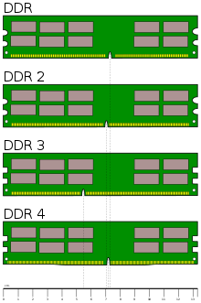](https://en.wikipedia.org/wiki/File:Desktop_DDR_Memory_Comparison.svg)

* **2005:** standards body [JEDEC](https://en.wikipedia.org/wiki/JEDEC) began working on a successor to DDR3 around 2005, about 2 years before the launch of DDR3 in 2007. The high-level architecture of DDR4 was planned for completion in 2008.
* **2007:** some advance information was published in 2007, and a guest speaker from [Qimonda](https://en.wikipedia.org/wiki/Qimonda" \o "Qimonda) provided further public details in a presentation at the August 2008 [San Francisco](https://en.wikipedia.org/wiki/San_Francisco) [Intel Developer Forum](https://en.wikipedia.org/wiki/Intel_Developer_Forum) (IDF). DDR4 was described as involving a 30 nm process at 1.2 volts, with bus frequencies of 2133 [MT/s](https://en.wikipedia.org/wiki/MT/s) "regular" speed and 3200 MT/s "enthusiast" speed, and reaching market in 2012, before transitioning to 1 volt in 2013.
* **2009:** in February, [Samsung](https://en.wikipedia.org/wiki/Samsung) validated 40 nm DRAM chips, considered a "significant step" towards DDR4 development since in 2009, DRAM chips were only beginning to migrate to a 50 nm process.
* **2010:** subsequently, further details were revealed at MemCon 2010, [Tokyo](https://en.wikipedia.org/wiki/Tokyo) (a computer memory industry event), at which a presentation by a JEDEC director titled "Time to rethink DDR4" with a slide titled "New roadmap: More realistic roadmap is 2015" led some websites to report that the introduction of DDR4 was probably or definitely delayed until 2015. However, DDR4 [test samples](https://en.wikipedia.org/wiki/Engineering_sample)were announced in line with the original schedule in early 2011 at which time manufacturers began to advise that large scale commercial production and release to market was scheduled for 2012.
* **2011:** in January, [Samsung](https://en.wikipedia.org/wiki/Samsung) announced the completion and release for testing of a 2 GB DDR4 DRAM module based on a process between 30 and 39 [nm](https://en.wikipedia.org/wiki/Nanometer). It has a maximum data transfer rate of 2133 [MT/s](https://en.wikipedia.org/wiki/MT/s) at 1.2 V, uses [pseudo open drain](https://en.wikipedia.org/wiki/Open_drain) technology (adapted from [graphics DDR](https://en.wikipedia.org/wiki/GDDR) memory) and draws 40% less power than an equivalent DDR3 module.   
  In April, [Hynix](https://en.wikipedia.org/wiki/Hynix) announced the production of 2 GB DDR4 modules at 2400 MT/s, also running at 1.2 V on a process between 30 and 39 nm (exact process unspecified), adding that it anticipated commencing high volume production in the second half of 2012. Semiconductor processes for DDR4 are expected to transition to sub-30 nm at some point between late 2012 and 2014.
* **2012:** in May, [Micron](https://en.wikipedia.org/wiki/Micron_Technology) announced it is aiming at starting production in late 2012 of 30 nm modules.  
  In July, Samsung announced that it would begin sampling the industry's first 16 GB registered dual inline memory modules (RDIMMs) using DDR4 SDRAM for enterprise server systems.  
  In September, JEDEC released the final specification of DDR4.
* **2013:** DDR4 was expected to represent 5% of the DRAM market in 2013, and to reach [mass market](https://en.wikipedia.org/wiki/Mass_market) adoption and 50% [market penetration](https://en.wikipedia.org/wiki/Market_penetration) around 2015 as of 2013, however, adoption of DDR4 has been delayed and it is no longer expected to reach a majority of the market until 2016 or later. The transition from DDR3 to DDR4 is thus taking longer than the approximately five years taken for DDR3 to achieve mass market transition over DDR2. In part, this is because changes required to other components would affect all other parts of computer systems, which would need to be updated to work with DDR4.
* **2014:** in April, Hynix announced that it had developed the world's first highest-density 128 GB module based on 8 [Gb](https://en.wikipedia.org/wiki/Gibibit) DDR4 using 20 nm technology. The module works at 2133 MHz, with a 64-bit I/O, and processes up to 17 GB of data per second.
* **2016:** in April, Samsung announced that they had begun to mass-produce DRAM on a "10 nm-class" process, by which they mean the 1x nm node regime of 16 nm to 19 nm, which supports a 30% faster data transfer rate of 3,200 [megabits](https://en.wikipedia.org/wiki/Megabit) per second. Previously, a size of 20 nm was used.

**Read Only Memory (ROM) –**

**ROM** is a type of non-volatile memory used in computers and other electronic devices. Data stored in ROM cannot be electronically modified after the manufacture of the memory device. Read-only memory is useful for storing software that is rarely changed during the life of the system, sometimes known as firmware. Software applications for programmable devices can be distributed as plug-in cartridges containing read-only memory.

Erasable programmable read-only memory (EPROM) and electrically erasable programmable read-only memory (EEPROM) can be erased and re-programmed, but usually this can only be done at relatively slow speeds, may require special equipment to achieve, and is typically only possible a certain number of times.

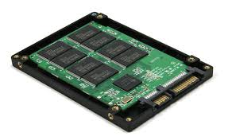

* Stores crucial information essential to operate the system, like the program essential to boot the computer.
* It is not volatile.
* Always retains its data.
* Used in embedded systems or where the programming needs no change.
* Used in calculators and peripheral devices.
* ROM is further classified into 4 types- *ROM*, *PROM*, *EPROM*, and *EEPROM*.

**Types of Read Only Memory (ROM) –**

1. **PROM (Programmable read-only memory)** – It can be programmed by user. Once programmed, the data and instructions in it cannot be changed.
2. **EPROM (Erasable Programmable read only memory)** – It can be reprogrammed. To erase data from it, expose it to ultra violet light. To reprogram it, erase all the previous data.
3. **EEPROM (Electrically erasable programmable read only memory)** – The data can be erased by applying electric field, no need of ultra violet light. We can erase only portions of the chip

**SSD**

An SSD (solid-state drive) is a type of nonvolatile storage media that stores persistent data on solid-state flash memory. Two key components make up an SSD: a flash controller and NAND flash memory chips. The architectural configuration of the SSD controller is optimized to deliver high read and write performance for both sequential and random data requests. SSDs are sometimes referred to as flash drives or solid-state disks.

SSDs will use three main types of memory:

* 1. Single cell
  2. Multi cell
  3. Triple-level cells

1. Single-level cells can hold one bit of data at a time—a one or zero. Single-level cells (SLC) are the most expensive form of SSD, but it is also the fastest and most durable.
2. Multi-level cells (MLC) can hold two bits of data per cell and have a larger amount of storage space in the same amount of physical space as SLC. However, MLCs have slower write speeds.
3. Triple-level cells (TLC) can hold three bits of data in a cell. TLCs have a lower price, but slower write speeds and less durability. TLC-based SSDs deliver more flash capacity and are cheaper than an MLC or SLC.

**Processor Architecture**

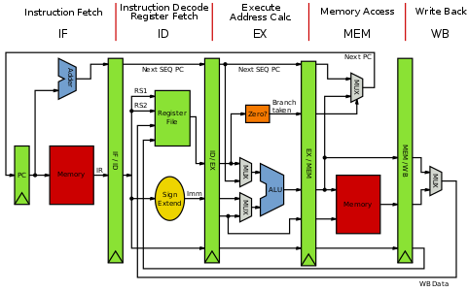

Core i5-8250U is a 64-bit quad-core performance x86 mobile microprocessor introduced by Intel in mid-2017.

This processor, which is based on an enhanced version of the Kaby Lake micro architecture, is manufactured on Intel's 2nd generation enhanced 14nm+ process. The i5-8250U operates at 1.6 GHz with a TDP of 15 W and Turbo Boost frequency of up to 3.4 GHz. This MPU supports up to 32 GiB of dual-channel DDR4-2400 memory and incorporates Intel's UHD Graphics 620 IGP operating at 300 MHz with a burst frequency of 1.15 GHz.

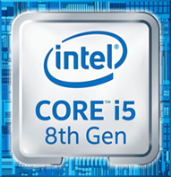

This model has a configurable TDP-down of 10 W at 800 MHz and a TDP (thermal design power)-up of 25 W at 1.8 GHz.

**General Architecture**

Since the 64-bit registers allow access for many sizes and locations, we define a byte as 8 bits, a word as 16 bits, a double word as 32 bits, a quad word as 64 bits, and a double quad word as 128 bits. Intel stores bytes “little endian,” meaning lower significant bytes are stored in lower memory address. shows sixteen general purpose 64-bit registers, the first eight of which are labeled (for historical reasons) RAX, RBX, RCX, RDX, RBP, RSI, RDI, and RSP. The second eight are named R8-R15. By replacing the initial R with an E on the first eight registers, it is possible to access the lower 32 bits (EAX for RAX).Similarly, for RAX, RBX, RCX, and RDX, access to the lower 16 bits is possible by removing the initial R (AX for RAX), and the lower byte of the these by switching the X for L (AL for AX), and the higher byte of the low 16 bits using an H (AH for AX).

**SIMD Architecture**

Single Instruction Multiple Data (SIMD) instructions execute a single command on multiple pieces of data in parallel and are a common usage for assembly routines. MMX and SSE commands (using the MMX and XMM registers respectively) support SIMD operations, which perform an instruction on up to eight pieces of data in parallel. For example, eight bytes can be added to eight bytes in one instruction using MMX.The eight 64-bit MMX registers MMX0-MMX7 are aliased on top of FPR0-7, which means any code mixing FP and MMX operations must be careful not to overwrite required values. The MMX instructions operate on integer types, allowing byte, word, and double word operations to be performed on values in the MMX registers in parallel.

**Working on Control Unit**

**Control Unit** is the part of the computer’s central processing unit (CPU), which directs the operation of the processor. It was included as part of the **Von Neumann Architecture** by John von Neumann. It is the responsibility of the Control Unit to tell the computer’s memory, arithmetic/logic unit and input and output devices how to respond to the instructions that have been sent to the processor. It fetches internal instructions of the programs from the main memory to the processor instruction register, and based on this register contents, the control unit generates a control signal that supervises the execution of these instructions.

A control unit works by receiving input information to which it converts into control signals, which are then sent to the central processor. The computer’s processor then tells the attached hardware what operations to perform. The functions that a control unit performs are dependent on the type of CPU because the architecture of CPU varies from manufacturer to manufacturer. Examples of devices that require a CU are:

* Control Processing Units(CPUs)
* Graphics Processing Units(GPUs)

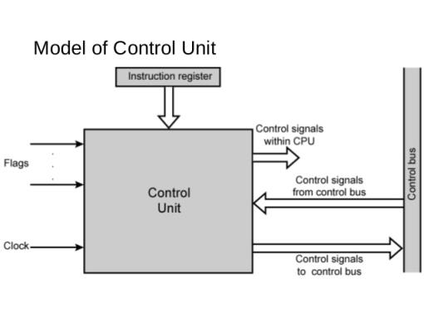

**Input & output mechanism**

**HDMI**

Stands for "High-Definition Multimedia Interface." HDMI is a trademark and brand name for a digital interface used to transmit audio and video data in a single cable. It is supported by modern audio/video equipment. HDMI outputs "feed" audio and video signals into the HDMI inputs of digital devices, which receive and process them. The cables are terminated with plug connectors, typically featuring 19 pins. Many A/V receivers contain digital processors that can take analog video signals, from a VHS or DVD player, and convert them to HMDI.

**USB**

USB" refers to Universal Serial Bus, which is a type of connection used to link computers to peripheral devices. USB ports are found on both the computers and the devices, and USB cables connect them to each other. USB ports function as both input and output ports. There are two types of USB ports, Type A and Type B, and information can go both directions on either one.

**USB Type A**

The most popular type of USB standard is Type A. You will most likely to find Type-A ports in host devices like desktop computers, gaming consoles and media players.

**USB Type B**

Type-B connectors are at the other end of a typical USB cable that plugs into a peripheral device, such as a smart phone, a printer or a hard drive.

**USB Type C**

Type-C over other existing variants is that it allows for ‘reverse plug orientation’. It can be also be used to share data, charging device.